31.20: Using 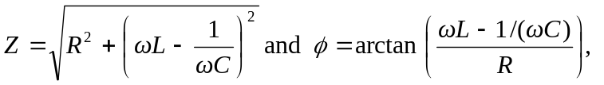 along with the values
a)
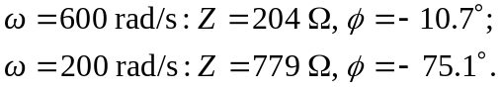
b) The current increases at first, then decreases again since 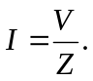
c) The phase angle was calculated in part (a) for all frequencies.
d)

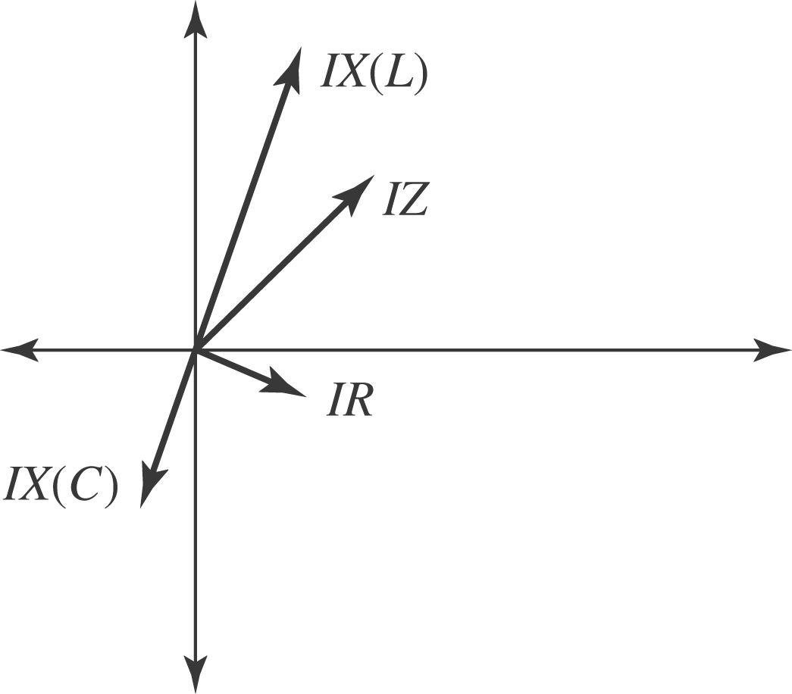

e)

